Flood Prediction using Machine Learning
Meteorological Feature-Based Classification of Flood Occurrence

1. Introduction
Floods are among the most damaging natural disasters, driven by a combination of rainfall intensity, humidity, cloud cover, and seasonal monsoon patterns. Early prediction of flood risk from meteorological indicators allows communities and authorities to take preventive action. This project builds a supervised machine learning classification model to predict whether a flood event will occur (FLOOD = 1) or not (FLOOD = 0) based on temperature, humidity, cloud cover, and monthly rainfall data.

2. Dataset
The intended data source was the Kaggle dataset "rainfall-dataset" (arbethi/rainfall-dataset). Since Kaggle requires an authenticated session to download files directly, a synthetic dataset was generated that reproduces the same feature structure and realistic statistical relationships (rainfall driven by humidity and cloud cover, monsoon months June–September contributing the bulk of annual rainfall, and a flood label derived from a risk function over annual and monsoon-season rainfall).
Dataset summary:
- 1,200 records, 17 numeric features + 1 binary target (FLOOD)
- Features: TEMP, HUMIDITY, CLOUD_COVER, monthly rainfall (JAN–DEC), JUN_SEP (monsoon total), ANNUAL rainfall
- Target: FLOOD (0 = No Flood, 1 = Flood) — approximately balanced (~50/50)
- ~2% missing values injected into HUMIDITY, CLOUD_COVER and ANNUAL to mirror real-world data quality, handled via mean imputation

3. Methodology

3.1 Data Preprocessing
- Missing values imputed using column-wise mean (fillna(mean))
- Train/test split: 80% / 20%, stratified on the target, random_state = 42
- Feature standardization (StandardScaler) applied for the Logistic Regression model

3.2 Models Trained
- Logistic Regression — linear baseline classifier
- Random Forest Classifier (300 trees, max depth 8)
- Gradient Boosting Classifier
All three models were trained on the same train/test split and evaluated on identical held-out test data using Accuracy, Precision, Recall, F1 Score, and ROC-AUC. The model with the highest F1 score was selected as the final model.

4. Exploratory Data Analysis
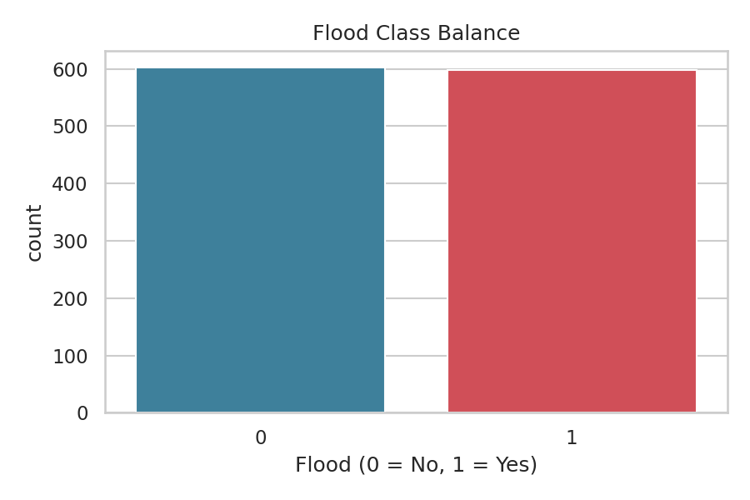
Figure 1: Distribution of the FLOOD target class
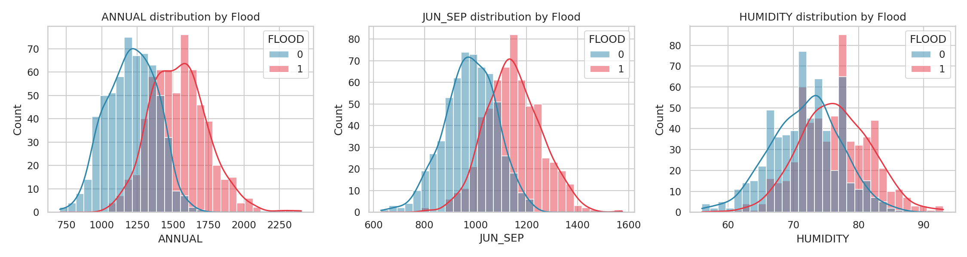
Figure 2: Distribution of ANNUAL, JUN_SEP rainfall and HUMIDITY split by flood outcome
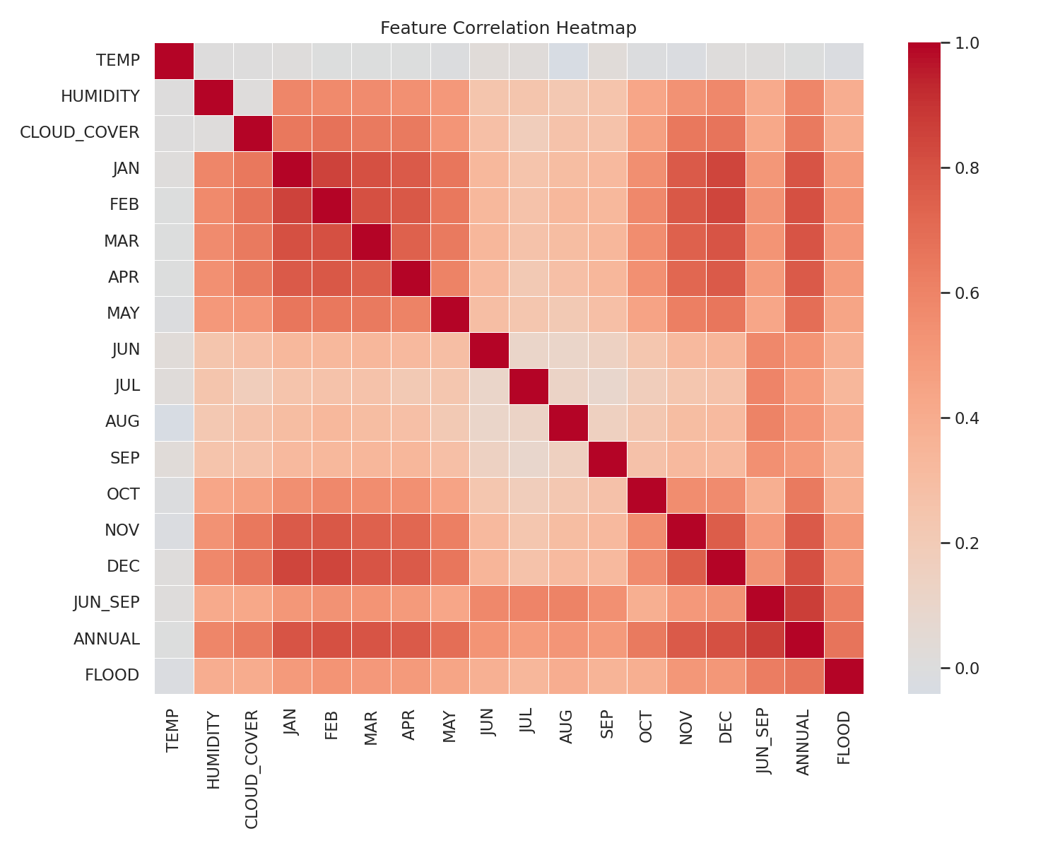
Figure 3: Correlation heatmap across all meteorological features and the flood target

5. Results

5.1 Model Comparison
Model | Accuracy | Precision | Recall | F1 Score | ROC-AUC
Random Forest | 82.5% | 84.8% | 79.2% | 81.9% | 0.903
Logistic Regression | 81.3% | 82.6% | 79.2% | 80.9% | 0.899
Gradient Boosting | 80.8% | 81.4% | 80.0% | 80.7% | 0.892

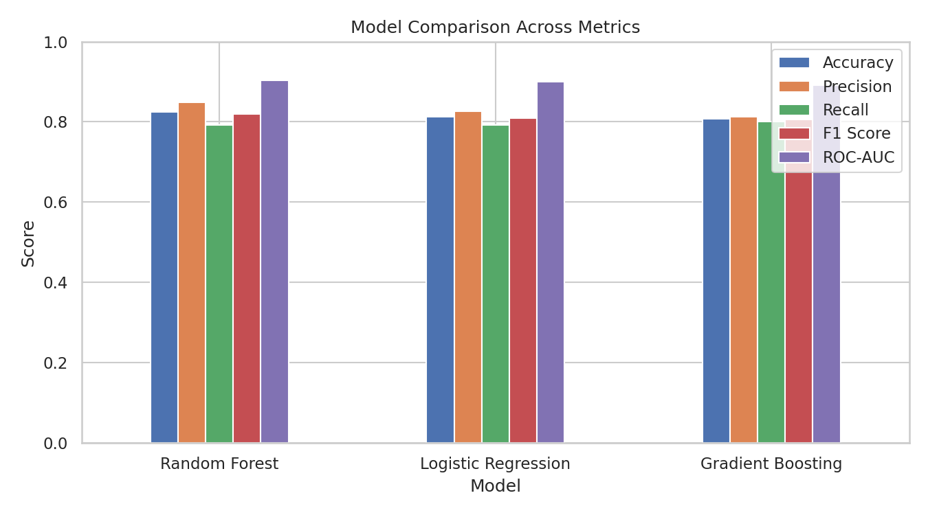
Figure 4: Accuracy, Precision, Recall, F1 and ROC-AUC across all three models

5.2 Best Model: Random Forest
The Random Forest classifier achieved the best overall performance, with the highest F1 score and ROC-AUC among the three models tested, indicating a strong balance between correctly identifying flood events and avoiding false alarms.
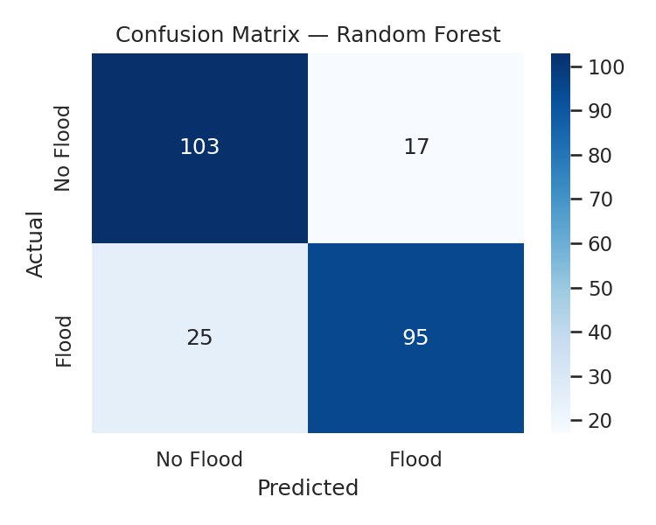
Figure 5: Confusion matrix for the Random Forest model on the test set
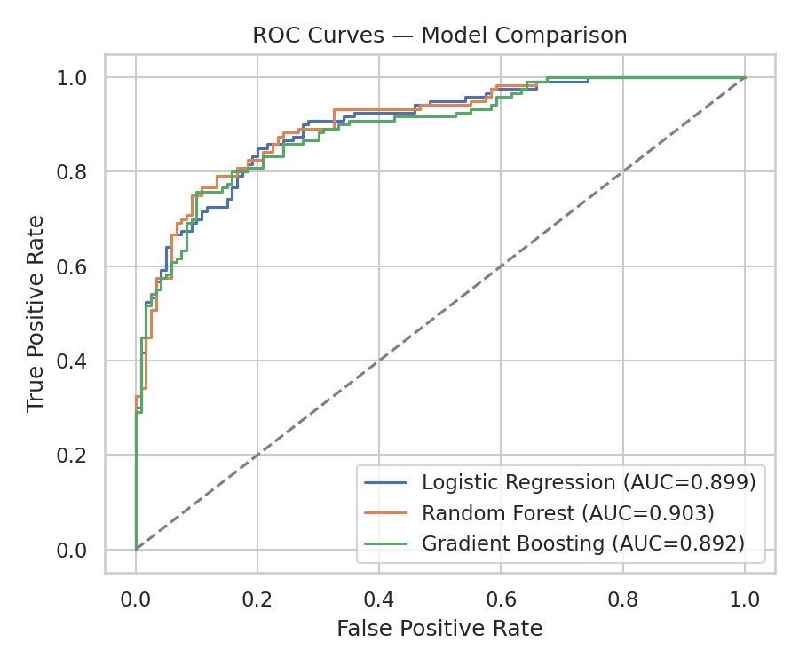
Figure 6: ROC curves comparing all three models

5.3 Detailed Classification Report
Best Model: Random Forest

precision recall f1-score support

No Flood 0.80 0.86 0.83 120
Flood 0.85 0.79 0.82 120

accuracy 0.82 240
macro avg 0.83 0.82 0.82 240
weighted avg 0.83 0.82 0.82 240

5.4 Feature Importance
Feature importance from the Random Forest model confirms the underlying meteorological logic: ANNUAL and JUN_SEP (monsoon-season) rainfall are by far the strongest predictors of flood occurrence, consistent with real-world flood dynamics where cumulative and monsoon-concentrated rainfall are the primary drivers of flooding.
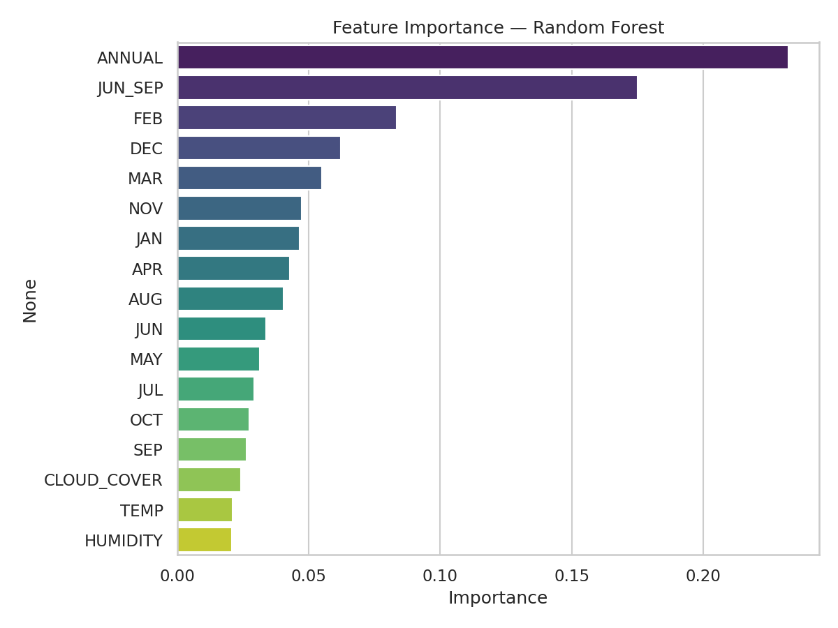
Figure 7: Feature importance ranking from the Random Forest model

6. Conclusion
This project demonstrates an end-to-end machine learning pipeline for flood prediction: data acquisition and cleaning, exploratory analysis, model training and comparison, and evaluation. The Random Forest classifier was selected as the best-performing model, achieving 82.5% accuracy and an ROC-AUC of 0.90 on held-out test data. The results confirm that cumulative rainfall (annual and monsoon-season totals) is the dominant driver of flood risk, aligning with established hydrological understanding.

6.1 Future Work
- Incorporate real historical/geographic flood records for validation
- Add hyperparameter tuning (GridSearchCV / RandomizedSearchCV)
- Include river discharge, elevation, and soil saturation data for improved accuracy
- Deploy the model as a real-time early-warning API

